**1.CREATING A SPRING BOOT APPLICATION**

* We have to go **start.spring.io** this will help us to add the required dependencies and it will also configure it.
* After visiting **start.spring.io** you will have to select the Maven project and the language in which you have to develop. I have selected Java and leave the default selection of Spring Boot, Java and in Packaging select of your requirement.
* Now we have to select the dependencies which we want in our project.

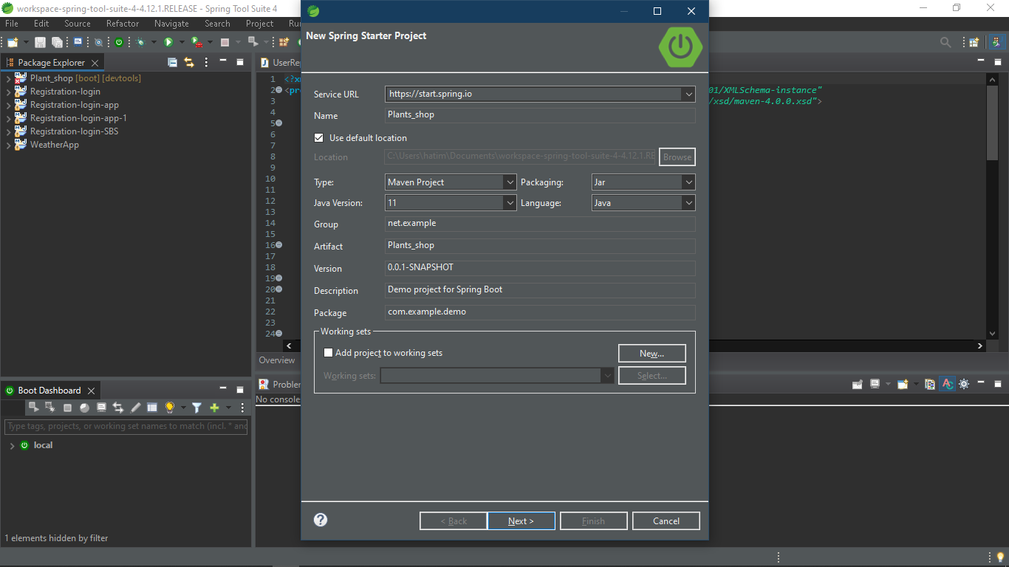

* After selecting the dependencies you will have to click on generate to generate a zip file .
* Next step is to browse the zip file and extract it.
* After extracting the file, open Eclipse and click on

**File <Import<Maven<Existing Maven Project**

* Browse for the extracted folder select it and click on finish and it will create a required environment for you.
* After finishing the project you will get the structure like this:

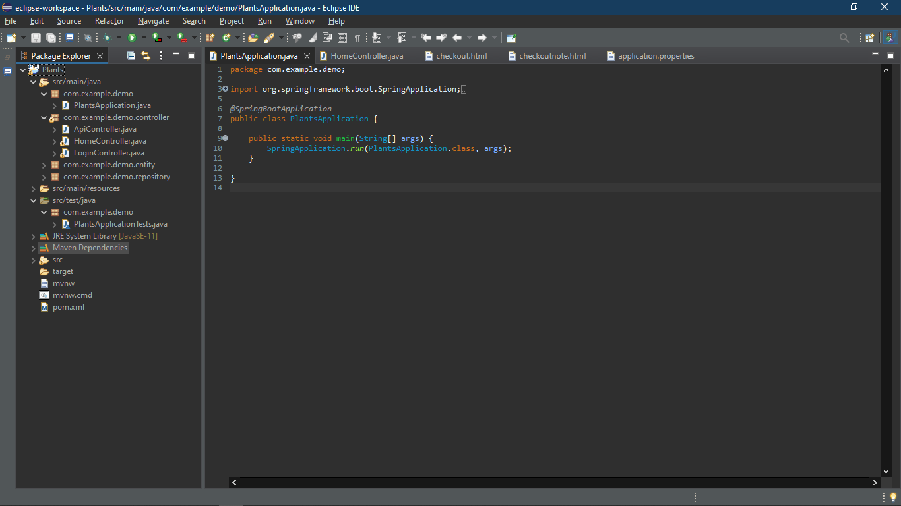

**2. Project Packaging Structure**

**src:**

* **src/main/java** – This folder contains Java source code packages and classes
* **src/main/resources** – This folder contains non-java resources, such as property files and Spring configuration, Css file, Html etc.

**package:**

* **src/test/java** – This folder contains the test source code packages and classes.
* **src/test/resources** – This folder contains non-Java resources, such as property files and Spring configuration.

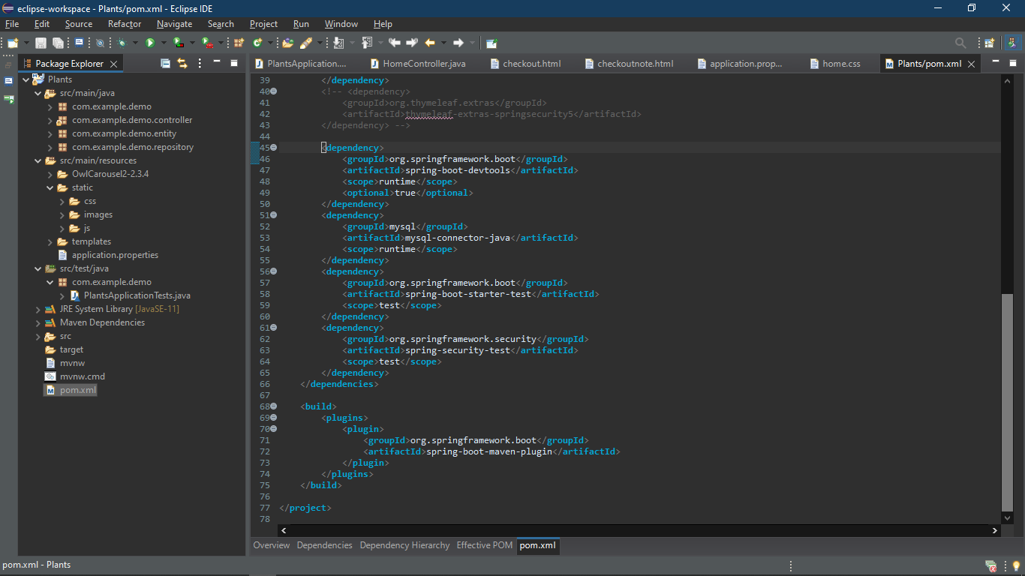

**3. Dependencies and Properties Folder**

* **pom.xml** contains the added dependencies which we have selected in start.spring.io.
* **application.properties** contains the connection between the application and Database.
* **JRE System Library** contains the libraries file and jar files.

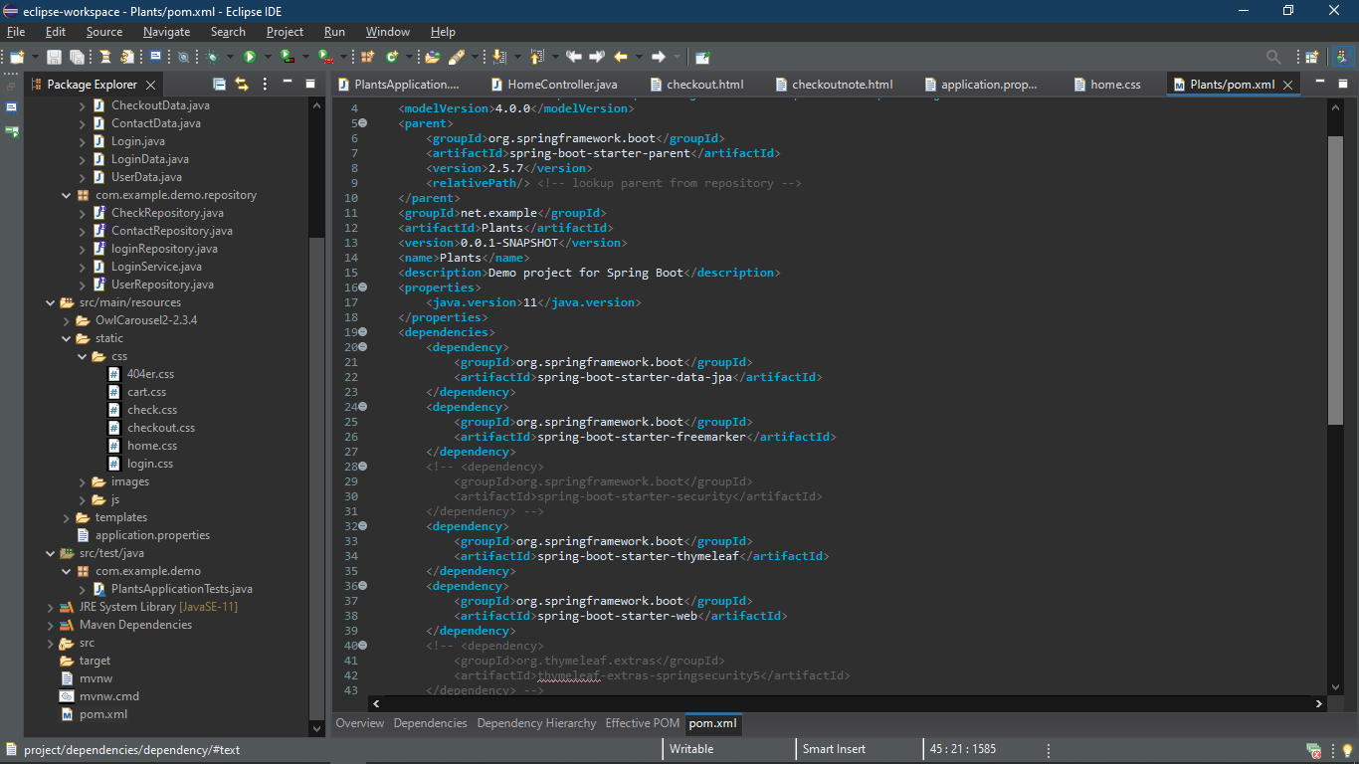

**4.Creating Packages,Interfaaces,Classes:**

**src/main/java**

1. Package(com.example.demo)

* Class(Application.java)

1. Package(com.example.demo.controller)

* Class(APIController.java)
* Class(HomeController.java)
* Class(LoginController.java)

1. Package(com.example.demo.entity)

* Class(CheckoutData.java)
* Class(ContactData.java)
* Class(LoginData.java)
* Class(UserData.java)
* Class(Login.java)

1. Package(com.example.demo.repository)

* Interface(CheckRepository.java)
* Interface(ContactRepository.java)
* Interface(loginRepository.java)
* Interface(UserRepository.java)
* Class(LoginService.java)

**src/test/java**

1. Package(com.example.demo)

* Class(ApplicationTests.java)

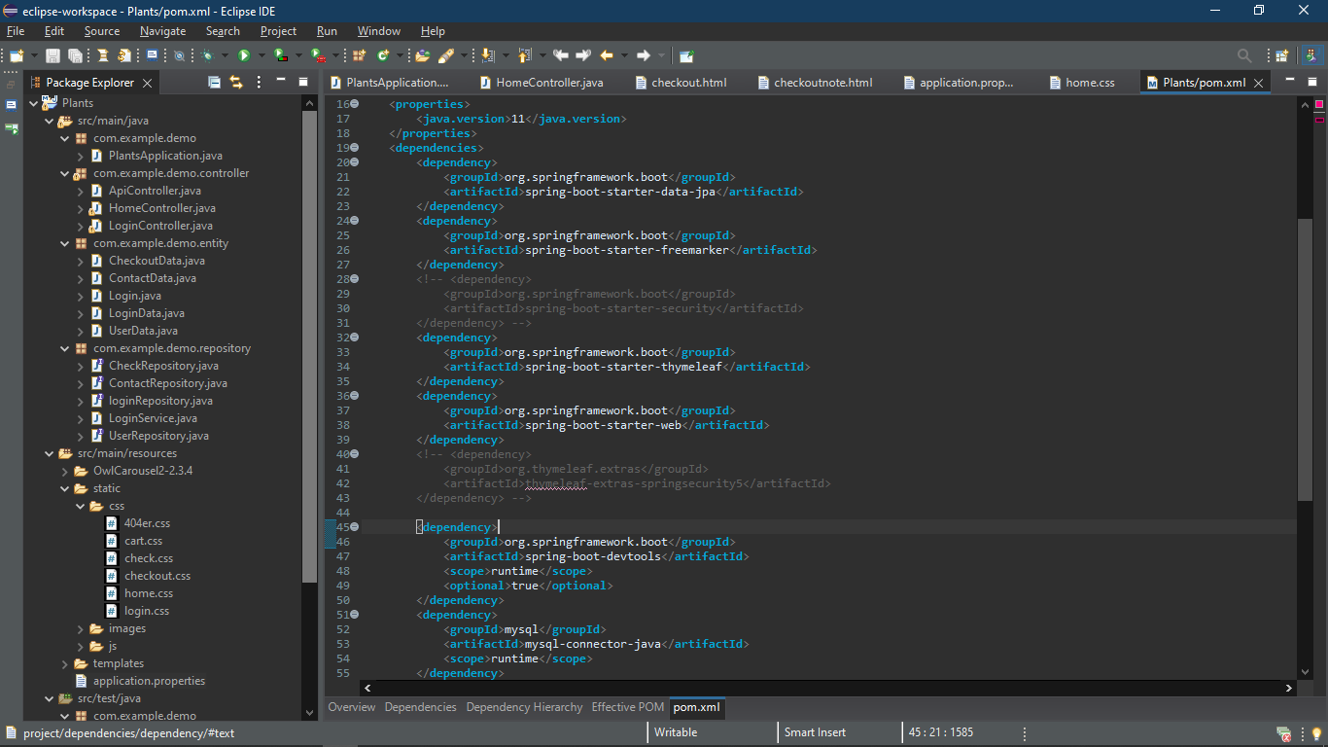

**5.Test Case**

